Day in the Life of the Hudson River 10/13/22
The Baylander
RIVER MILE: 10
Salt Front: ~ RM 76
The Baylander Scott Koen & PS 36 (5th graders)- Shari Fine
18 students & 4 adults
Latitude 40.819303 N & Longitude – 73.961445 W
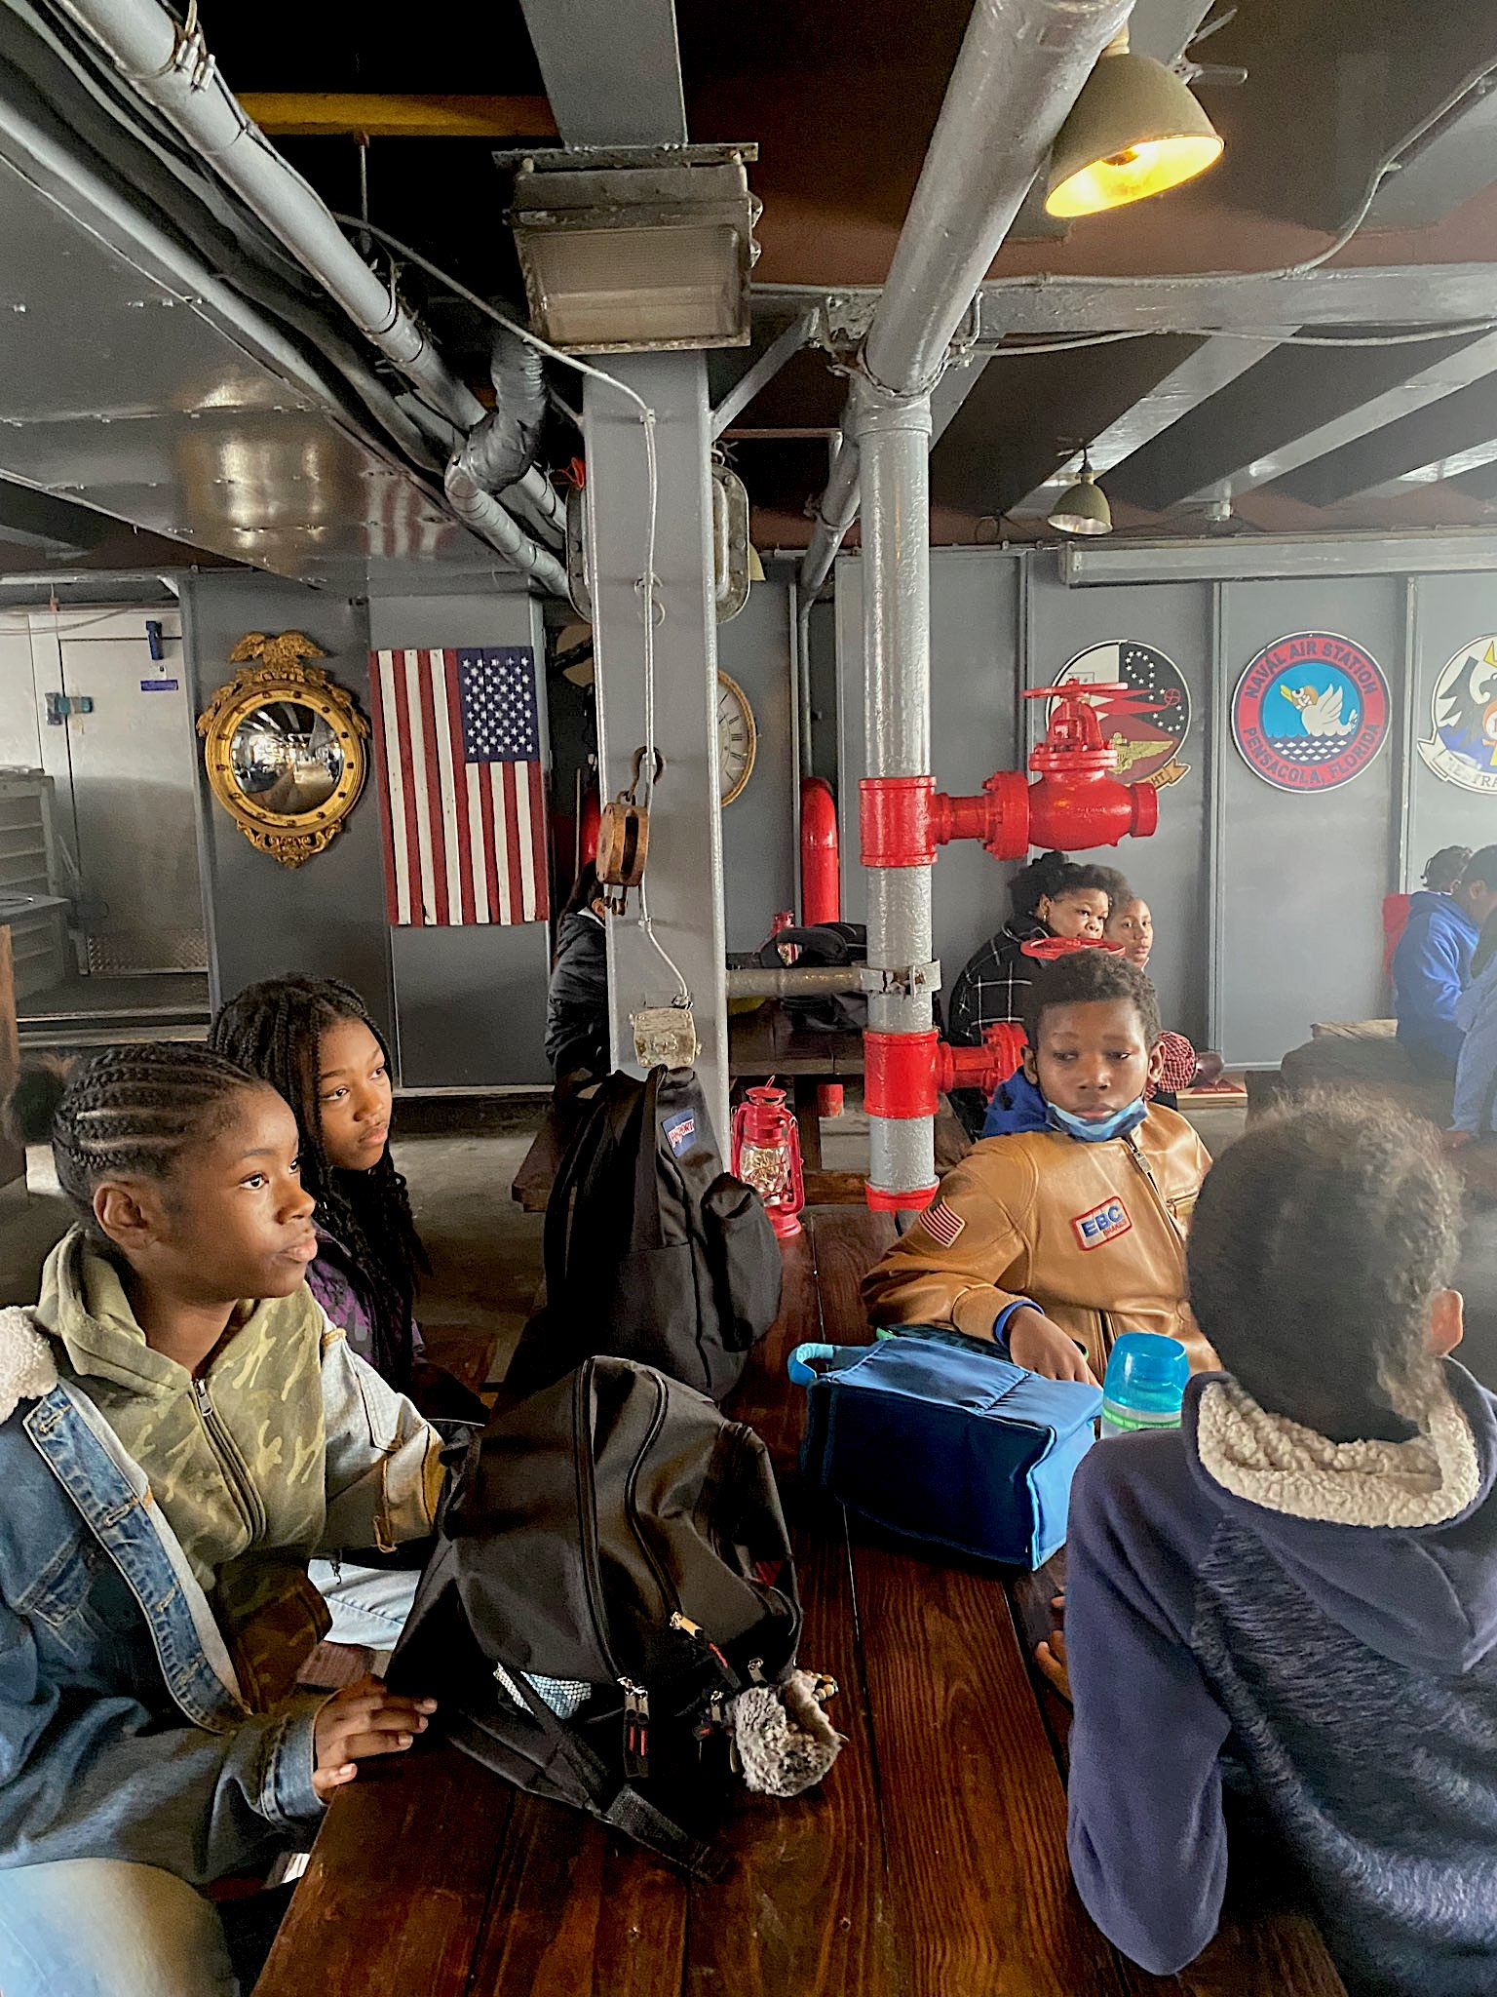 | 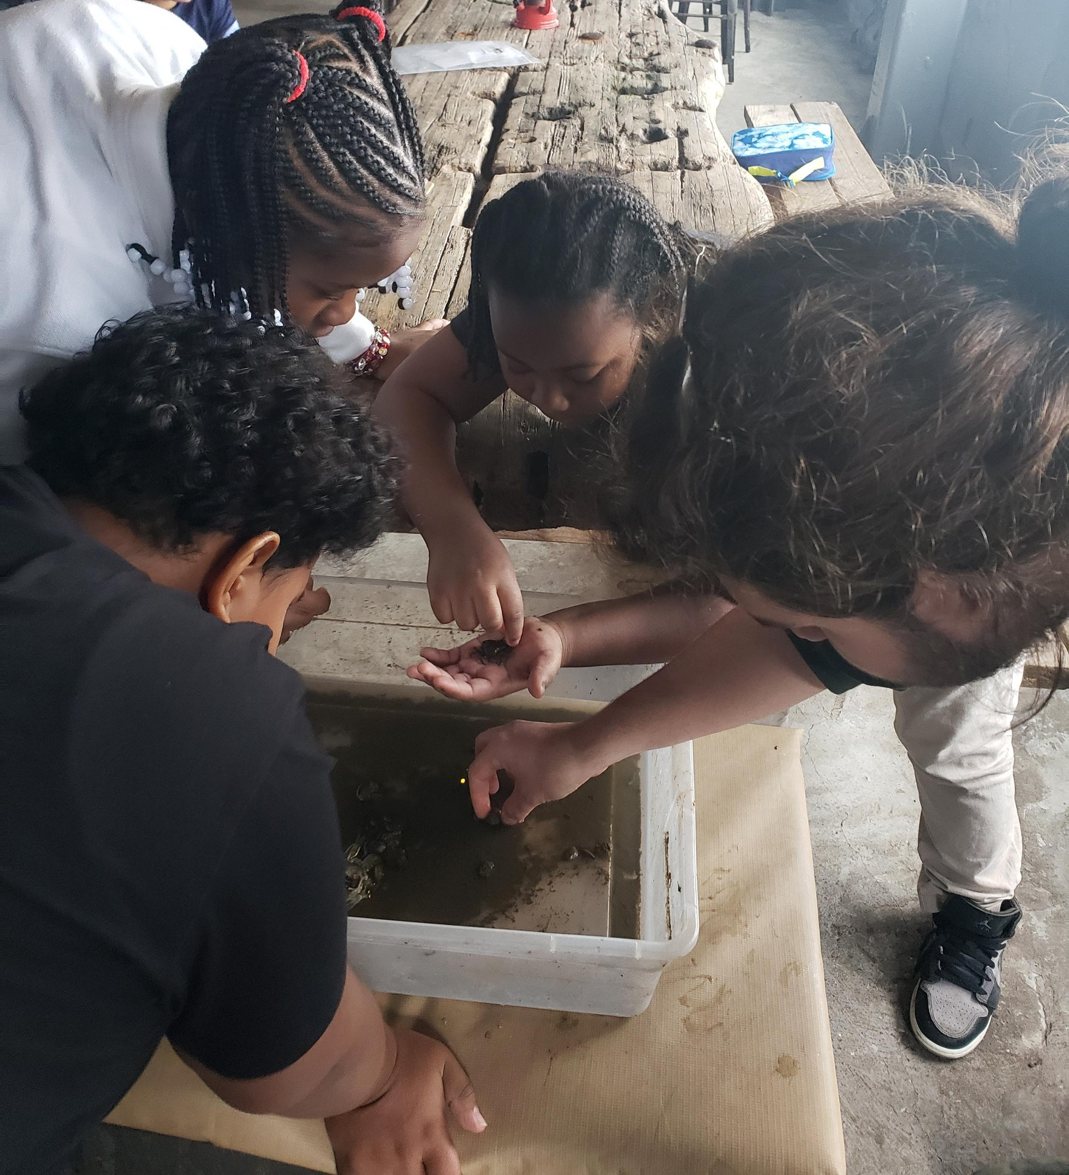 | 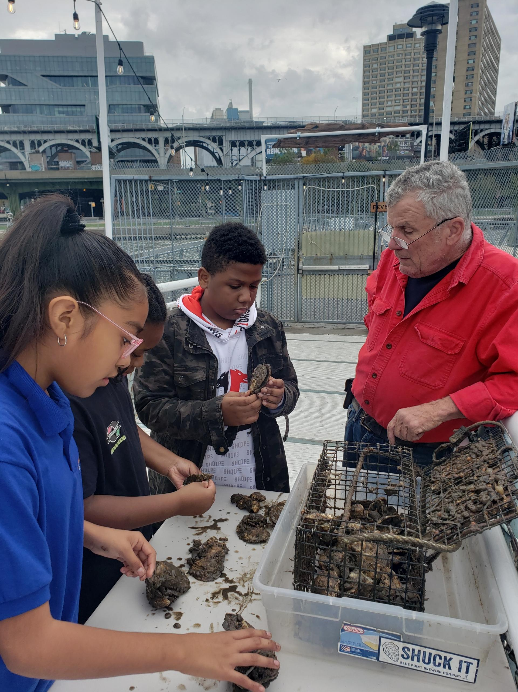 | 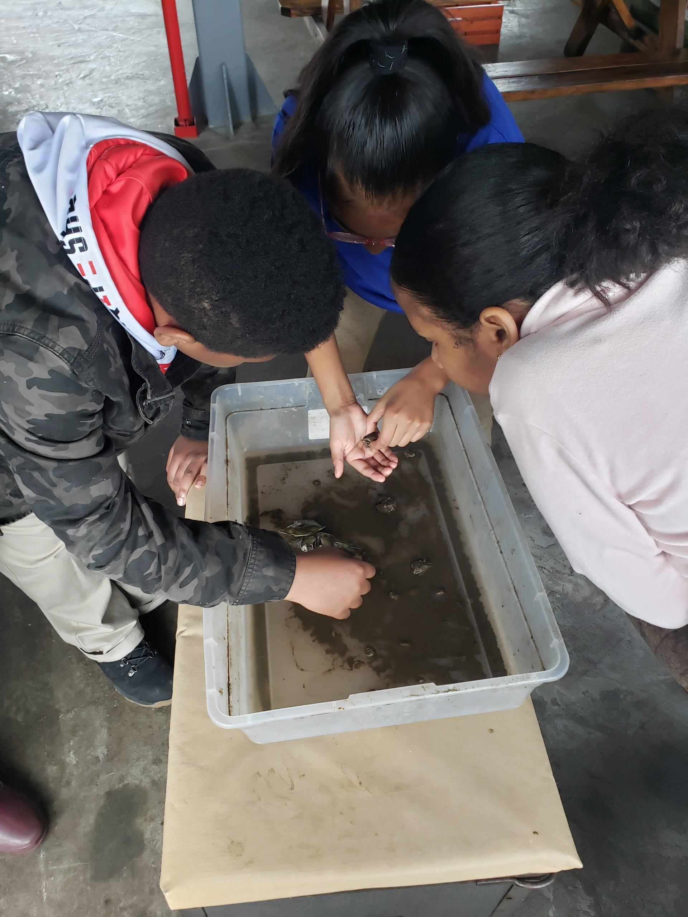

Location: Baylander
Area: Pier with lots of water, birds, and houses in the distance
Surrounding Land Use: 75% Urban/Residential; 25% other
Sampling Site: Pier, pipe entering the water
Shoreline: 100% Rocky
Water: Choppy
Plants in the water: no plants in the water
River Bottom: muddy, sandy, rocky, weedy
*NR = Not read/recorded
ITEM |  | Time |  | Reading |  |  |  | Comments
Physical
Air Temperature- |  | 9:35 AM  9:46 AM |  | 21.7°C  23.2°C |  |  | 71°F  73.7°F
Wind Speed: |  | 9:35 AM |  | Anemometer  2.7 knots |  |  | Beaufort  1 | Direction
Weather today |  | 9:43 AM |  | >75% cloud cover |  |  | No Rain
Weather the past 3 days: |  | Sunny, partly cloudy, cool
Tides- NR |  | Time |  | Rising, Falling, Unchanged |  |  | Water Height (cm)
Current- NR |  | Time |  | Cm/sec |  | Knots | North/South | Ebb/Flood/Still
Water Temperature- |  | 9:25 AM  9:52 AM  10:04 AM |  | 19.5°C  20°C  19°C |  |  | 67°F  68°F  66°F
Turbidity- Secchi Disk (cm) |  | 9:30 AM  9:52 AM  10:13 AM |  | 91.44 cm  91.44 cm  76.2 cm
Chemical
Salinity-Hydrometer |  | 9:25 AM  9:52 AM  10:04 AM |  | 16 ppt  17 ppt  18 ppt
Standardized Salinity – Refractometer |  | 9:20 AM |  | 16,000 ppm
DO – |  | Time  10:02 AM |  | Temp  19°C |  |  | ppm DO  8 ppm | % saturation  90%
pH – Color Match Kit |  | 9:37 AM  9:40 AM |  | 7  7.5
Nitrates- NR
Phosphates- NR
Alkalinity- NR
Biological
Fish – Traps |  | Number |  | Name |  |  | Length of longest | Length of smallest
Fish Totals |  | TOTAL:0 |  | Diversity: 0
Macroinvertebrates |  | Number |  | Name |  |  | Length of longest | Length of smallest
 |  | 1  2 |  | Blue Crab  Mud Crab
Macroinvertebrate Totals |  | TOTAL: 3 |  | Diversity:2 |  |  |  | *oysters, sea grapes and mussels attached to oyster shells
Sediment Core - NA
Length | H2S smell |  | Oxid Top |  | Oil |  | Grain Size | Other Features
Boats-NR
 | Time |  | Name |  | Color |  | North/Southbound | Light/Loaded

